**Geometric Structures of statistical Physics, Information Geometry and Learning**

***Ecole de Physique des Houches SPIGL’20 Summer Week***

**SPRINGER Proceedings in Mathematics & Statistics, 2021**

**Subject**This book is Proceedings of Les Houches Summer Week SPIGL’20 (Joint Structures and Common Foundation of **S**tatistical **P**hysics, **I**nformation Geometry and Inference for **L**earning) organized from 26th to 31st July 2020 at L’Ecole de Physique des Houches:

* Website: <https://franknielsen.github.io/SPIG-LesHouches2020/>
* Videos: <https://www.youtube.com/playlist?list=PLo9ufcrEqwWExTBPgQPJwAJhoUChMbROr>

The conference SPIGL’20 has developed the following topics:

* ***Geometric Structures of Statistical Physics and Information***
  + Statistical Mechanics and Geometric Mechanics
  + Thermodynamics, Symplectic and Contact Geometries
  + Lie groups Thermodynamics
  + Relativistic and continuous media Thermodynamics
  + Symplectic Integrators
* ***Physical structures of inference and learning***
  + Stochastic gradient of Langevin's dynamics
  + Information geometry, Fisher metric and natural gradient
  + Monte-Carlo Hamiltonian methods
  + Varational inference and Hamiltonian controls
  + Boltzmann machine

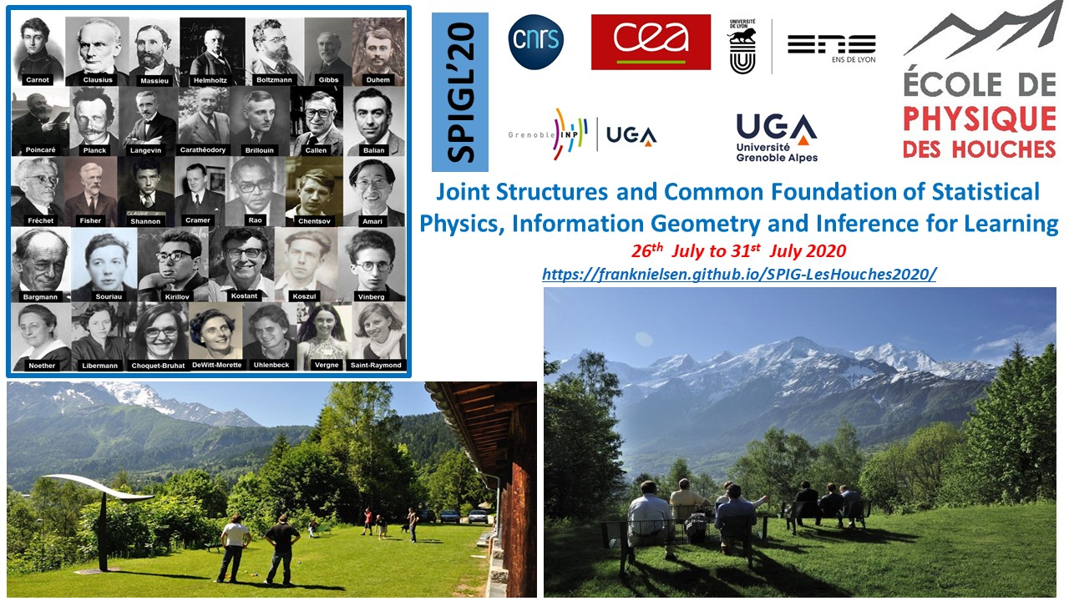

**Organizers**

***Frédéric Barbaresco***, THALES, KTD PCC, Palaiseau

***Silvère Bonnabel,*** Mines ParisTech, CAOR, Paris

***Géry de Saxcé,*** Université de Lille, LaMcube, Lille

***François Gay-Balmaz***, Ecole Normale Supérieure Ulm, CNRS & LMD, Paris

***Bernhard Maschke,*** Université Claude Bernard, LAGEPP, Lyon

***Eric Moulines***, Ecole Polytechnique, CMAP, Palaiseau

***Frank Nielsen***, Ecole Polytechnique, LIX, Palaiseau & SONY CSL, Tokyo

**Scientific Rational**

In the middle of the last century, Léon Brillouin in "The Science and The Theory of Information" or André Blanc-Lapierre in "Statistical Mechanics" forged the first links between the Theory of Information and Statistical Physics as precursors.

In the context of Artificial Intelligence, machine learning algorithms use more and more methodological tools coming from the Physics or the Statistical Mechanics. The laws and principles that underpin this Physics can shed new light on the conceptual basis of Artificial Intelligence. Thus, the principles of Maximum Entropy, Minimum of Free Energy, Gibbs-Duhem's Thermodynamic Potentials and the generalization of François Massieu's notions of characteristic functions enrich the variational formalism of machine learning. Conversely, the pitfalls encountered by Artificial Intelligence to extend its application domains, question the foundations of Statistical Physics, such as the construction of stochastic gradient in large dimension, the generalization of the notions of Gibbs densities in spaces of more elaborate representation like data on homogeneous differential or symplectic manifolds, Lie groups, graphs, tensors, ....

Sophisticated statistical models were introduced very early to deal with unsupervised learning tasks related to Ising-Potts models (the Ising-Potts model defines the interaction of spins arranged on a graph) of Statistical Physics. and more generally the Markov fields. The Ising models are associated with the theory of Mean Fields (study of systems with complex interactions through simplified models in which the action of the complete network on an actor is summarized by a single mean interaction in the sense of the mean field).

The porosity between the two disciplines has been established since the birth of Artificial Intelligence with the use of Boltzmann machines and the problem of robust methods for calculating partition function. More recently, gradient algorithms for neural network learning use large-scale robust extensions of the natural gradient of Fisher-based Information Geometry (to ensure reparameterization invariance), and stochastic gradient based on the Langevin equation (to ensure regularization), or their coupling called "Natural Langevin Dynamics".

Concomitantly, during the last fifty years, Statistical Physics has been the object of new geometrical formalizations (contact or symplectic geometry, ...) to try to give a new covariant formalization to the thermodynamics of dynamic systems. We can mention the extension of the symplectic models of Geometric Mechanics to Statistical Mechanics, or other developments such as Random Mechanics, Geometric Mechanics in its Stochastic version, Lie Groups Thermodynamic, and geometric modeling of phase transition phenomena.

Finally, we refer to Computational Statistical Physics, which uses efficient numerical methods for large-scale sampling and multimodal probability measurements (sampling of Boltzmann-Gibbs measurements and calculations of free energy, metastable dynamics and rare events, ...) and the study of geometric integrators (Hamiltonian dynamics, symplectic integrators, ...) with good properties of covariances and stability (use of symmetries, preservation of invariants, ...). Machine learning inference processes are just beginning to adapt these new integration schemes and their remarkable stability properties to increasingly abstract data representation spaces.

Artificial Intelligence currently uses only a very limited portion of the conceptual and methodological tools of Statistical Physics. The purpose of this conference is to encourage constructive dialogue around a common foundation, to allow the establishment of new principles and laws governing the two disciplines in a unified approach. However, it is also about exploring new « chemins de traverse ».

Frédéric Barbaresco & Frank Nielsen

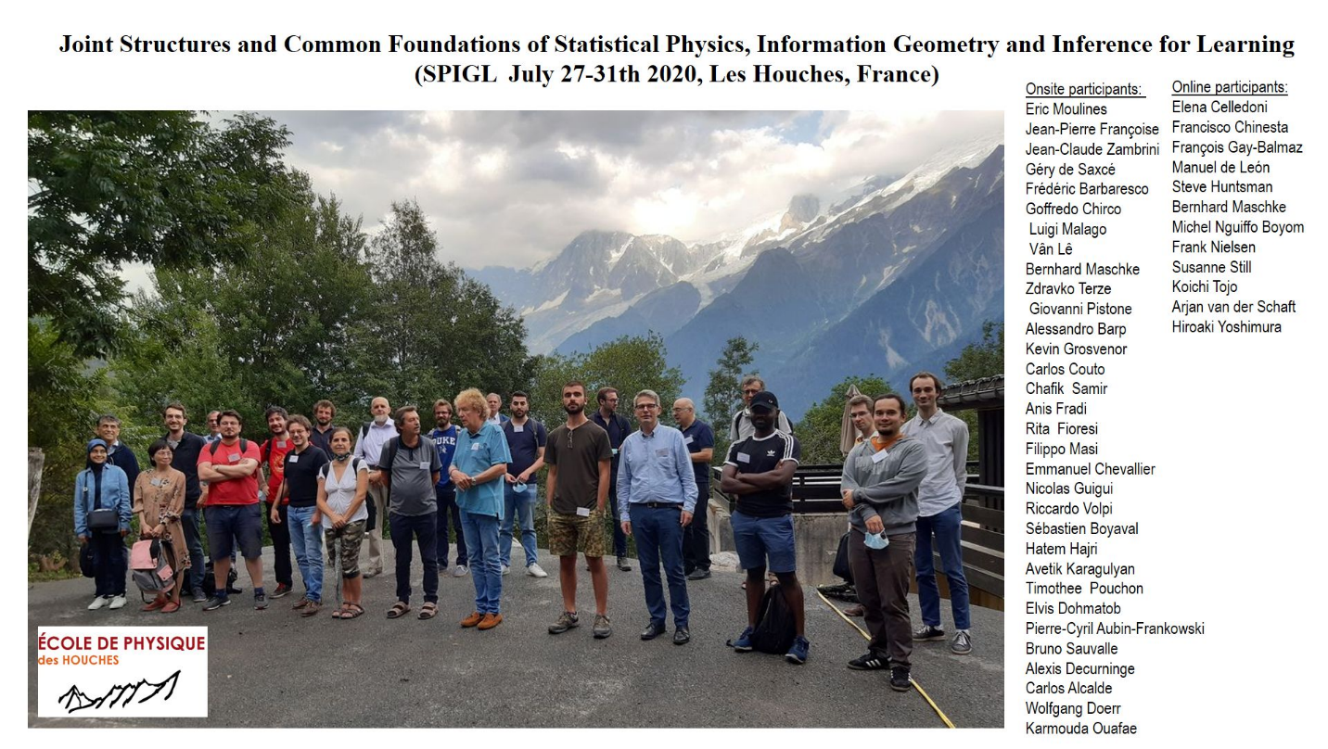

Main contributors in Thermodynamics, Statistical Physics, Information Geometry and Lie Group Representation Theory:

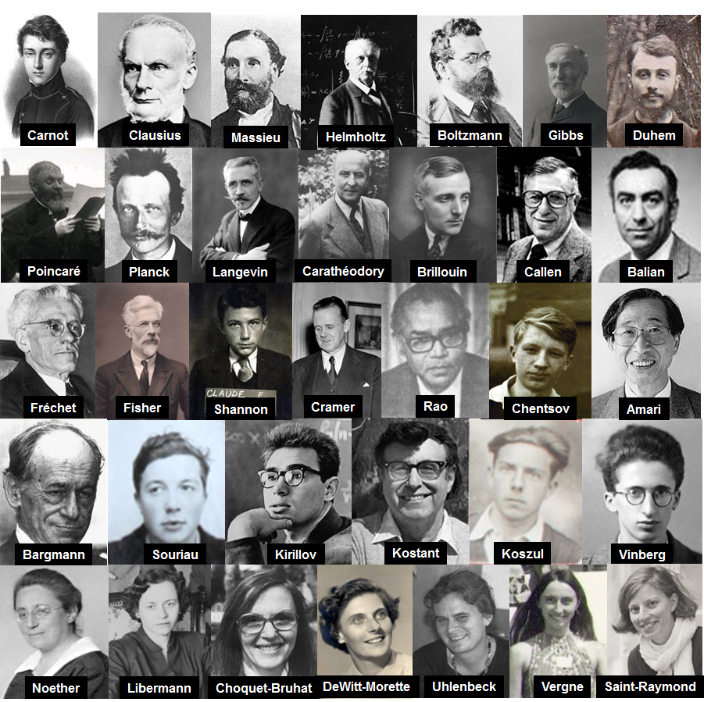

CONTENTS

**Tribute to Jean-Marie Souriau seminal works**

* 14 - Géry de Saxcé and Charles-Michel Marle, Structure des Systèmes Dynamiques Jean-Marie Souriau’s book 50th birthday
* 6 - Frédéric Barbaresco, Jean-Marie Souriau’s Symplectic Model of Statistical Physics : Seminal papers on Lie Groups Thermodynamics - Quod Erat Demonstrandum

**Lie Group Geometry & Diffeological Model of Statistical Physics and Information Geometry**

* 5 - Frédéric Barbaresco, Souriau-Casimir Lie Groups Thermodynamics & Machine Learning
* 12 - Koichi Tojo and Taro Yoshino, An exponential family on the upper half plane and its conjugate prior
* 17 - Emmanuel Chevallier and Nicolas Guigui, Wrapped statistical models on manifolds: motivations, the case SE(n), and generalization to symmetric spaces
* 15 - Géry de Saxcé, Galilean Thermodynamics of Continua
* 10 - Hông Vân Lê and Alexey Tuzhilin, Nonparametric estimations and the diffeological Fisher metric

**Advanced Geometrical Models of Statistical Manifolds in Information Geometry**

* 1 - Jean-Pierre Francoise, Information Geometry and Integrable Hamiltonian Systems
* 19 - Michel Nguiffo Boyom, Relevant Differential topology in statistical manifolds
* 13 - Giovanni Pistone, A lecture about the use of Orlicz Spaces in Information Geometry
* 3 - Frank Nielsen and Gaëtan Hadjeres, Quasiconvex Jensen divergences and quasiconvex Bregman divergences

**Geometric Structures of Mechanics, Thermodynamics & Inference for Learning**

* 8 - François Gay-Balmaz and Hiroaki Yoshimura, Dirac Structures and Variational Formulation of Thermodynamics for Open Systems
* 20 - Alexandre Anahory Simoes, David Martín de Diego, Manuel Lainz Valcázar and Manuel de León, The geometry of some thermodynamic systems
* 4 - Francisco Chinesta, Elias Cueto, Miroslav Grmela, Beatriz Mioya, Michal Pavelka and Martin Sipka, Learning Physics from Data: a Thermodynamic Interpretation
* 21 - Zdravko Terze, Viktor Pandža, Marijan Andrić and Dario Zlatar, Computational dynamics of reduced coupled multibody-fluid system in Lie group setting
* 9 - Filippo Masi, Ioannis Stefanou, Paolo Vannucci and Victor Maffi-Berthier, Material modeling via Thermodynamics-based Artificial Neural Networks
* 11 - Kevin Grosvenor, Information Geometry and Quantum Fields

**Hamiltonian Monte Carlo, HMC Sampling and Learning on Manifolds**

* 18 - Alessandro Barp, The Geometric Integration of Measure-Preserving Flows for Sampling and Hamiltonian Monte Carlo
* 7 - Anis Fradi, Ines Adouani and Chafik Samir, Bayesian inference on local distributions of functions and multidimensional curves with spherical HMC sampling
* 2 - Steve Huntsman, Sampling and Statistical Physics via Symmetry
* 16 - Thomas Gerald, Hadi Zaatiti and Hatem Hajri, A Practical hands-on for learning Graph Data Communities on Manifolds